

MAAR

LONG BIOGRAPHY (184 words)

MAAR is the latest endeavour from long-time collaborators and friends Ösp Eldjárn, Valeria Pozzo, and Helga Ragnars. Two-thirds Icelandic, one-third Italian, the trio first crossed paths in London in 2011, when a chance house-share sparked a lasting musical connection.

After years of collaborating and performing in each other’s solo projects, the three songwriters have now joined forces to create their new collaborative project.

In the summer of 2024, the trio retreated to a cabin in rural Iceland, where they wrote the three songs that will appear on their debut EP, The Wave, due to be released in June 2026.

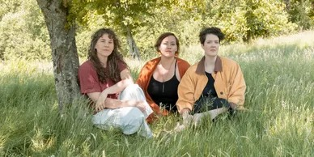
MAAR’s music is characterised by three-part vocal harmonies, intimate lyrics, and acoustic instrumentation. At the heart of their sound is the interplay of all three members’ voices, creating a dynamic and harmonious identity that’s uniquely their own. Shaped by collaboration and friendship, their music is intimate, and unforced. It flows like a conversation between close friends.

MAAR have been performing in England and Wales in the summer of 2025, and are touring Iceland in July 2026. They are currently working on their first full album.

SHORT BIOGRAPHY (50 words)

The latest endeavour from songwriters Ösp Eldjárn, Valeria Pozzo, and Helga Ragnars.

In 2024 the trio retreated to a cabin in rural Iceland, and wrote their debut EP The Wave, out in June 2026.

MAAR’s music is characterised by three-part vocal harmonies, intimate lyrics, and acoustic instrumentation.

FACEBOOK | INSTAGRAM | YOUTUBE | BANDCAMP

For further information, please contact Ant Miles at Fancourt Music ant.miles@fancourtmusic.com +44 7837 881941

